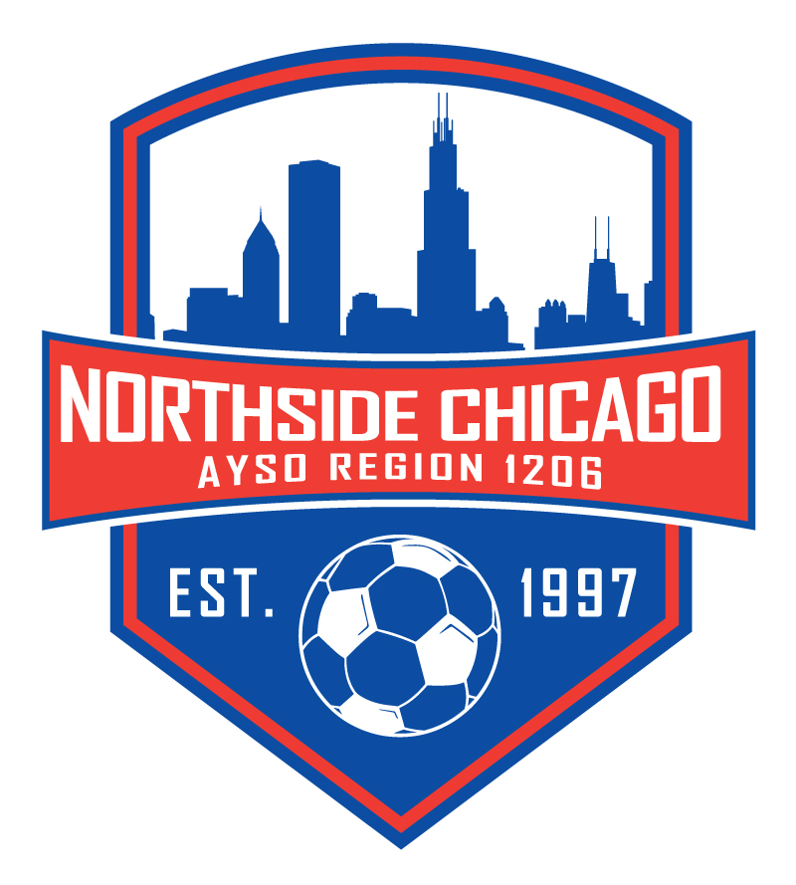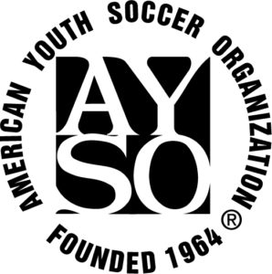

**Northside Chicago AYSO Region 1206**

**Scholarship/Financial Assistance Form**



**Everyone Plays means that financial need won’t prevent your child from playing soccer with Northside Chicago AYSO. We follow the Chicago Park District guidelines for Financial Assistance. Fill out the form below and provide requested documents outlined on page 2.**

|  |  |  |  |  |  |
| --- | --- | --- | --- | --- | --- |
| **Date of Application** *(MM/DD/YYY)***:** | |  | | | |
| **Parent / Guardian’s Name:** | |  | | | |
| **Email:** | |  | | | |
| **Phone Number:** | |  | | | |
| **Scholarship Request:** *Fill out for every player needing assistance* | | | | | |
|  | **Player Name** | | |  | **Date of Birth** *(MM/DD/YY)* |
| **Player (1):** |  | | |  |  |
| **Player (2):** |  | | |  |  |
| **Player (3):** |  | | |  |  |
| **Player (4):** |  | | |  |  |
| **Amount You Can Afford:** *Cost Per Player is $225 for Fall/Spring Season 2024/25* | | | | | |
| **I Can Afford $ Per Player:** | | |  | | |
| **Request a Payment Plan *(Yes/No):*** | | |  | | |
| **If Applicable, please state circumstances in which scholarship is needed:** | | | | | |
|  | | | | | |
|  | | | | | |
|  | | | | | |

Families are asked to present **ONE** of the following to demonstrate financial need.

1.  **State of Illinois – Department of Human Services Notice of Decision – Summary Section** confirming participation in Cash, Medical, or SNAP benefits. This notice accompanies the issuance of a LINK/EBT card. Reissued notices may be requested from your caseworker at a DHS Family Community Resource Center. Paying family must be listed as the benefits recipient.

2.  **State of Illinois – Healthcare and Family Services Medical Card** (not any other medical or insurance card). The child being enrolled in soccer must be listed as a covered person and paying family must be listed as Case Name.

3.  **Proof of income** that shows the household falls below the U.S. Department of Health & Human Services-determined Federal Poverty Guideline, by providing one of two options:

* Check stubs from the last 30 days to determine net monthly income, for the paying customer; must be parent or guardian of child being enrolled.  
  **OR**
* Previous Year’s IRS form (1040, 1040A, or 1040EZ) and corresponding W2, for the paying customer; must be parent or guardian of child being enrolled.

Information submitted is confidential. Documents will be reviewed by Northside Chicago AYSO Board member(s) and returned to the family; copies will not be made or retained.

If approved, Financial Assistance may cover up to half of the cost of registration.  Families are responsible for paying the remainder.

***Applicants that do not qualify for Financial Assistance may inquire about the payment plan option***.

**________________________________________________________________**

**For AYSO Region 1206 to Complete**

|  |  |
| --- | --- |
| **Total Region will Pay:** |  |
| **Documents Reviewed by:** |  |
| **Date Approved:** |  |